Statistics 31, Section 1, Midterm I
Tuesday, February 15, 2005

Name: _______________________________________________________

Pledge: I have neither given nor received aid on this examination.

Signature: _____________________________________________________

Instructions: Do not do any actual numerical calculations (e.g. answers in a form that you would type into an Excel field, with a working answer, are expected).

1. [20] Data, in the form of a time plot, for the average annual interest rate ofTreasury Bills during the 1990s is:
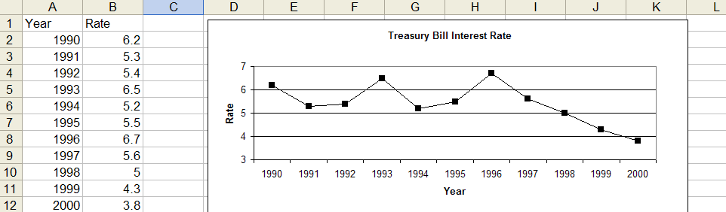
- Which statement best describes the behavior of the rate over the decade:
  - There was a general upward trend though the whole decade.
  - Rates peaked in 1994, and then continually tapered off.
  - There was a noticeable periodicity through the whole decade.
  - The rate was periodic early in the decade, then went through a steady decline.

- In which years did the rate reach temporary peaks?

- Write an EXCEL command to compute the correlation between Rate and Year.

- Write an EXCEL command to give the least squares prediction of the rate in 2001.

2. [30] The gradesheet from a past statistic class, with some summary statistics, is:
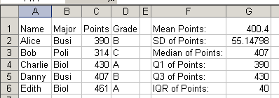

- What are the individuals and the variables in these data?

- Which variables are categorical and which are numerical?

- Write the EXCEL command that was used to compute cell G5.

- Identify all outliers, using the 1.5 x IQR rule

- What is the relative frequency of Biol Majors?

- Write an EXCEL command to give the Z-score for Bob’s Points.

3. [20] The same set of data were analyzed using 3 different bin grids, and gave these histograms:

- Which histogram best fills the description “oversmoothed, important detail is gone”?

- Which histogram best fills the description “smoothed about right, important detail is present”?

- Which statement best describes the overall population shape?

- Symmetric
- Left Skewed
- Right Skewed

- Which statement best describes the relationship between the mean and the median?

- The mean is smaller that the median
- The mean and median are quite close to each other.
- The mean is bigger than the median.

- Do there appear to be any candidates for potential outliers? If so, indicate the outliers.

4. [15] The length of pregnancies vary according to an approximate normal distribution, with mean 200 and standard deviation 20. Use the 68-95-99.7 rule to answer:

- Between what values do the middle 68% of all pregnancies fall?

- What percent of the data lie between 140 and 260?

- How long do the longest 2.5% last?

5. [15] A software company tests the effectiveness of its educational software on cell biology, against a standard textbook, by pre-testing a group of students, which are then randomly assigned to one of two groups. One group learns cell biology from the software, and the other from the text. Then both groups are again tested to assess increase in knowledge. Choose True or False for the following:

T F This is an observational study, because the company assigned the students to the two different groups, which were then compared.

T F This is an observational study, because some of the students learned from the text and others learned from the software.

T F This is a designed experiment, because the company assigned the students to the two different groups, which were then compared.

T F This is a designed experiment, because some of the students learned from the text and others learned from the software.

T F “Using the software” or “reading the book” are the “treatments”.

T F The response variable is what treatment was used.

T F The explanatory variable is the improvement in scores.

