Statistics - OR 155, Section 2, Midterm I
Tuesday, February 27, 2007

Name: ______________Solution_________________________________

Pledge: I have neither given nor received aid on this examination.

Signature: _____________________________________________________

Instructions: Do not do any actual numerical calculations (e.g. answers in a form that you would type into an Excel field, with a working answer, are expected).

1. [16] A survey of a large college class asked the following questions. The results for each are summarized in the histograms below. Match each question with it histogram.

a. How many minutes do you study on a typical weeknight?

b. Are you right or left handed (right = 0, left = 1)?

c. What is your height in inches?

d. Are you male or female (male = 0, female = 1).

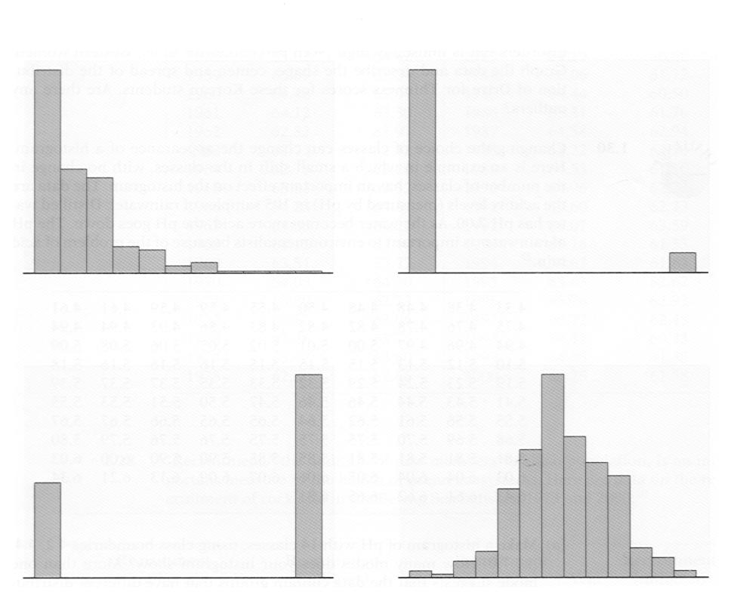
2. [20] Motor vehicles for sale are classified as either cars or light trucks, and are also classified as either imported or domestic. The proportion of cars is 30%, while the overall proportion of imported vehicles is 20%, and 6% were imported cars.

C or LT, D or I, P{C} = 0.3, P{I} = 0.2, P{C & I} = 0.06

a. Find the probability that a randomly chosen vehicle is a light truck.

P{LT} = 1 – P{not LT} = 1 – P{C} = 1 – 0.3 = 0.7

b. Find the probability that a randomly chosen vehicle is a car or is imported.

P{C or I} = P{C} + P{I} – P{C & I} = 0.3 + 0.2 – 0.06 = 0.44

c. Find the probability that a randomly chosen vehicle is not a domestic light truck

P{not(LT & D)} = P{(not LT) or (not D)} = P{C or I} = 0.3 + 0.2 – 0.06 = 0.44

d. Find the probability that a randomly chosen vehicle is a domestic light truck.

P{LT & D} = 1 – P{not(LT & D)} = 1 – (0.3 + 0.2 – 0.06) = 1 – 0.44 = 0.56

e. If a randomly chosen vehicle is known to be domestic, then find the probability that it is a light truck.

P{LT | D} = P{LT & D} / P{D} = 0.56 / (1 – P{I}) = (1 – (0.3 + 0.2 – 0.06)) / (1 – 0.2) =

= 0.56 / (1 – 0.2) = 0.56 / 0.8 = 0.7
3. [24] The distribution of recent ACT scores is approximately normally distributed, with mean 40, and standard deviation 5. SAT scores are roughly normally distributed with mean 1050 and standard deviation 40.

a. How well must Bert do on the ACT in order to place in the top quarter of students?

= NORMINV(1 – 0.25, 40, 5)

b. Beth scores 1170 on the SAT. About what fraction of students score had a lower score?

= NORMDIST(1170,1050,40,true)

c. Art scores 45 on the ACT, and Sam scores 1090 on the SAT. Who has the higher score?

Zart = (45 – 40) / 5 = 1, Zsam = (1090 – 1050) / 40 = 1, so they are the same

d. What percentage scored more than 38 on the ACT?

= (1 – NORMDIST(38,40,5,true)) * 100

(multiply by 100, to put proportion on percent scale)

e. What are the quartiles of the SAT distribution?

Q1 = NORMINV(0.25,1050,40)

Q3 = NORMINV(0.75,1050,40)

f. Use the 68-95-99.7 rule to find the range of 2.5% best scores on the ACT.

Mean + 2 * sd = 40 + 2 * 5, so range is 50 (= 40 + 2 * 5) and up

4. [20] The mean height of women is about 1.4 m, with a standard deviation of 0.08 m. The mean height of men is about 1.6 m, with a standard deviation of 0.1 m. Suppose the correlation of the heights of husbands and wives is 0.25.

xbar = 1.6, sx = 0.1, ybar = 1.4, sy = 0.08, r = 0.25

a. What is the slope of the regression line of the wife’s height on the husband’s height?

b = r * sy / sx = 0.25 * 0.08 / 0.01 = 0.2

b. Assuming the answer to part (a) is in the Excel cell T23, what is the intercept of the regression line of the wife’s height on the husband’s height?

A = ybar – b * xbar = 1.4 – T23 * 1.6 = 1.4 – 0.2 * 1.6 = 1.08

c. Suppose the numerical answer to part (a) is 0.2, and the numerical answer to part (b) is 1.08. Then, what is the equation of the regression line of the wife’s height on the husband’s height?

y = 0.2 x + 1.08

d. Predict the height of the wife of a man who is 1.8 m tall.

y0 = a * x0 + b = 0.2 * 1.8 + 1.08 = 1.44

e. Use the 68-95-99.7 rule to approximate the probability that a randomly chosen husband will be between 1.3 and 1.9 m in height.

Range is 1.3 to 1.9, which has endpoints 1.6 +- 3 * 0.1

So have region within 3 sd of mean, so Prob = 99.7%
5. [20] Choose a young adult at random. The probability is 0.10 that the person did not complete high school, 0.20 that the person has a high school diploma, but no further education, and 0.40 that the person has at least a bachelor’s degree.

P{<HS} = 0.1, P{=HS} = 0.2, P{>=B} = 0.4

a. What must be the probability that a randomly chosen young adult has some education beyond high school, but does not have a bachelor’s degree?

Only missing case is event {>HS & <B}.

Must have 1 = P{<HS} + P{=HS} + P{>HS & <B} + P{>=B} = 0.1 + 0.2 + P{>HS & <B} + 0.4

So P{>HS & <B} = 1 – (0.1 + 0.2 + 0.4) = 0.3

b. What is the probability that a randomly chosen young adult completed high school.

P{>=HS} = 1 – P{<HS} = 1 – 0.1 = 0.9

c. What is the probability that a randomly chosen young adult has no education beyond high school?

P{<=HS} = P{<HS or = HS} = P{<HS} + P{=HS} – 0 = 0.1 + 0.2 = 0.3

d. What is the probability that a randomly chosen young adult either did not finish high school, or else has at least a bachelor’s degree.

P{<HS or >=B} = P{<HS} + P{>=B} – 0 = 0.1 + 0.4 = 0.5

e. What is the probability that a randomly chosen young adult, who has finished high school, has a bachelor’s degree?

P{>=B | >=HS} = P{>=B & >=HS} / P{>=HS} = P{>=B} / P{>=HS} = 0.4 / 0.9

